Predicting Employee Attrition
Bakang Thebe
Student ID: 240136
Kent login: bt310



Table of Contents:
- Introduction
- Data Overview
- Data cleaning and Preparation
- Visualization
- Model Implementation and results
- Model Comparison
- Conclusion
- Appendix
Introduction:
Employee attrition is the rate at which employees leave an organization over a specific period. High attrition can lead to significant financial costs for firms. These costs include recruitment expenses, lower productivity, and disruptions to ongoing projects. Therefore, being able to identify employees who are likely to leave is valuable for human resource departments and workforce planning. With more HR-related data available, machine learning techniques provide a practical way to model attrition risk. By examining employee characteristics, job roles, satisfaction metrics, income levels, and organizational structure, predictive models can spot patterns that differentiate employees likely to stay from those expected to leave. This project aims to create a predictive model for employee attrition.
Dataset Overview:
The dataset (“IBM HR Analytics Employee Attrition & Performance”) contains various demographic, behavioral, and job-related variables for several employees. The target variable is "Attrition", indicating whether an employee has left the company (Yes) or stayed (No). The objective of this project is to build classification models that can accurately predict attrition based on the available features.
Data Cleaning and Preparation:
The dataset was first examined for data quality issues to ensure reliability and suitability for modeling:
- Missing Values: There were no missing values in the dataset.
- Duplicate Rows: The dataset was scanned for duplicate records, and no duplicates were found.
- Removal of Irrelevant Columns: Some columns were removed because they didn’t provide useful information for the analysis. For example, EmployeeCount, StandardHours, and Over18 had the same value for every employee, so they couldn’t help in predicting attrition. The EmployeeNumber column was also dropped because it was just an ID number that uniquely identified each employee and didn’t relate to whether someone might leave the company.
- Target Encoding: The Attrition column, which shows whether an employee left the company, originally used the words "Yes" and "No". This was changed to numbers. 1 for "Yes" and 0 for "No". This allows for easy use in the prediction models.
- Categorical Encoding: Categorical variables such as JobRole, MaritalStatus, and BusinessTravel were converted into numerical formats to make them suitable for modeling. Label encoding was used for models that accept factor inputs (e.g., GLM), while one-hot encoding was applied for models that require purely numeric input (e.g., neural networks).
- Data Type Conversion: Variables were turned into appropriate formats (e.g., factors, numeric) where necessary.
These cleaning steps ensured that the data was well-structured, free from redundancy, and ready for modeling.
Visualization:
A series of visualizations were created to explore patterns and potential relationships between employee characteristics and attrition. Bar plots showed clear differences in attrition rates across job roles and overtime status, with employees working overtime experiencing noticeably higher attrition. Boxplots and histograms revealed that employees with lower monthly income and those in younger age groups were more likely to leave. These insights helped guide feature selection and provided an initial understanding of which factors may be predictive of attrition.
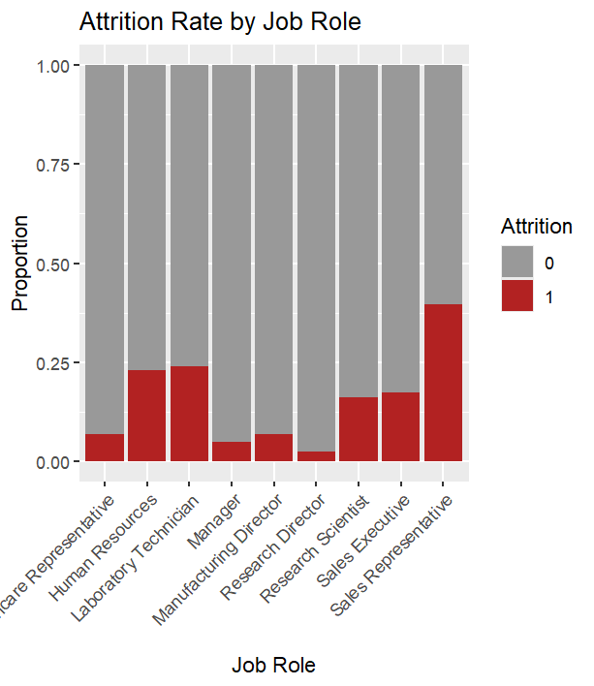
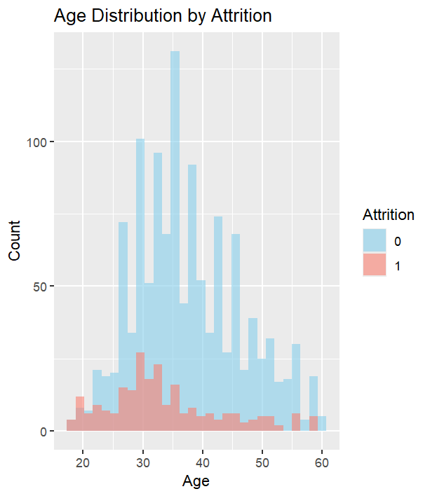

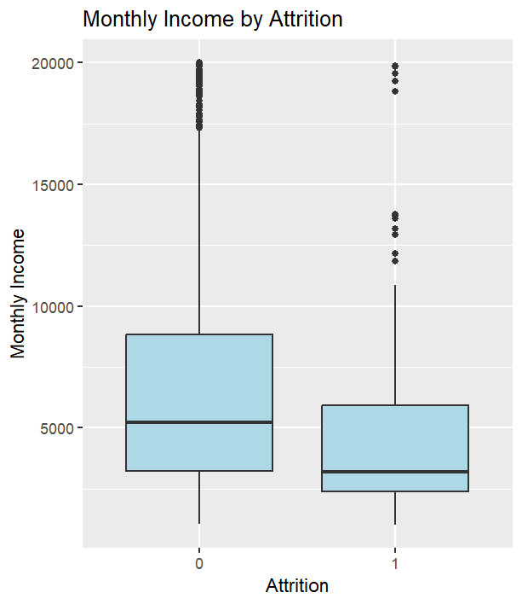
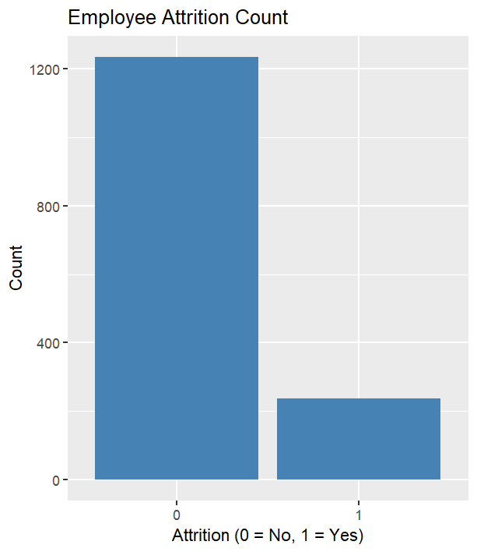

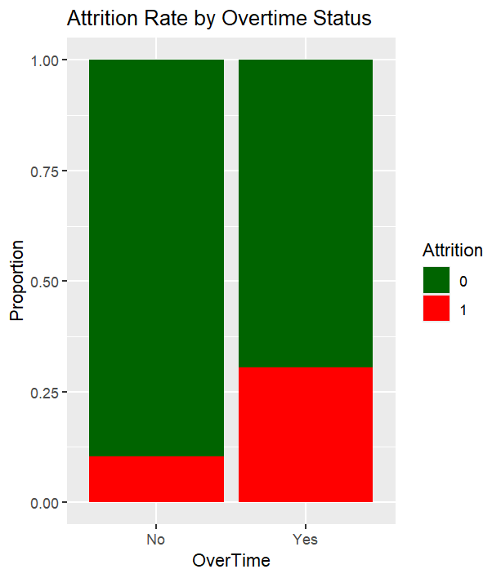

Model Implementation and Results:
The goal of modelling in this project is to help predict which employees are likely to leave the company, and to understand what factors influence that decision. By analysing past employee data, we can find patterns that may help HR teams act early and improve employee retention.
Modelling also helps explain which features (like job role, overtime, or salary) are most important in predicting attrition. This provides both useful forecasts and insights that can support better decision-making.
The following three models were used in this project:
- Logistic Regression (GLM) - a simple, interpretable model that shows how each factor affects the likelihood of attrition
- Random Forest – a flexible model that handles complex patterns well and shows which features are most important
- Deep Learning – a more advanced model that can capture hidden relationships in the data and make strong predictions
Using a mix of models helps balance accuracy with interpretability.

Logistic Regression (GLM)
A logistic regression model was used to predict employee attrition using the binomial family. The model included a range of predictors such as age, job role, business travel frequency, distance from home, income, satisfaction ratings, and more.
Model Formula and Summary
The model formula included all available predictors after preprocessing. Coefficient estimates and significance levels are displayed in Figure 1.

Several variables were statistically significant (p < 0.05), including:
- Age
- BusinessTravel_Travel_Frequently
- OverTime
- JobInvolvement, JobSatisfaction, and WorkLifeBalance

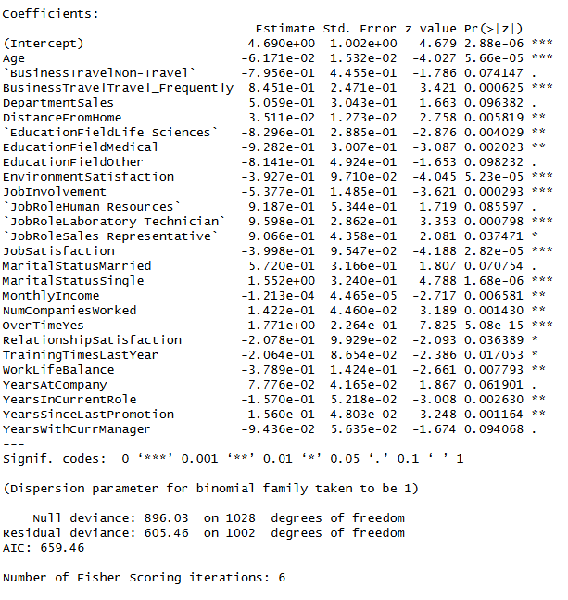

Odds Ratios:
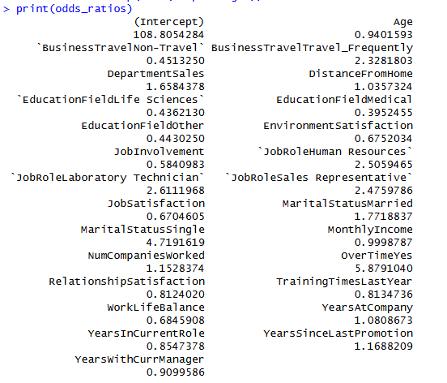
Exponentiating the model coefficients helped interpret the effects. For example:
- Employees who frequently travel were 2.33× more likely to leave.
- Those who work overtime were 5.88× more likely to leave.
- Employees with higher satisfaction and involvement had lower odds of leaving (OR < 1).

Model Evaluation:
A confusion matrix was produced to evaluate classification performance on the test set:
- Accuracy: 87.8%
- Sensitivity (Class 0): 97.3%
- Specificity (Class 1): 41.3%
- Balanced Accuracy: 69.3%

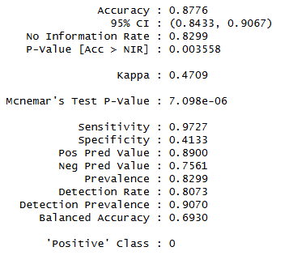
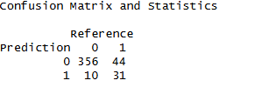

Roc Curve
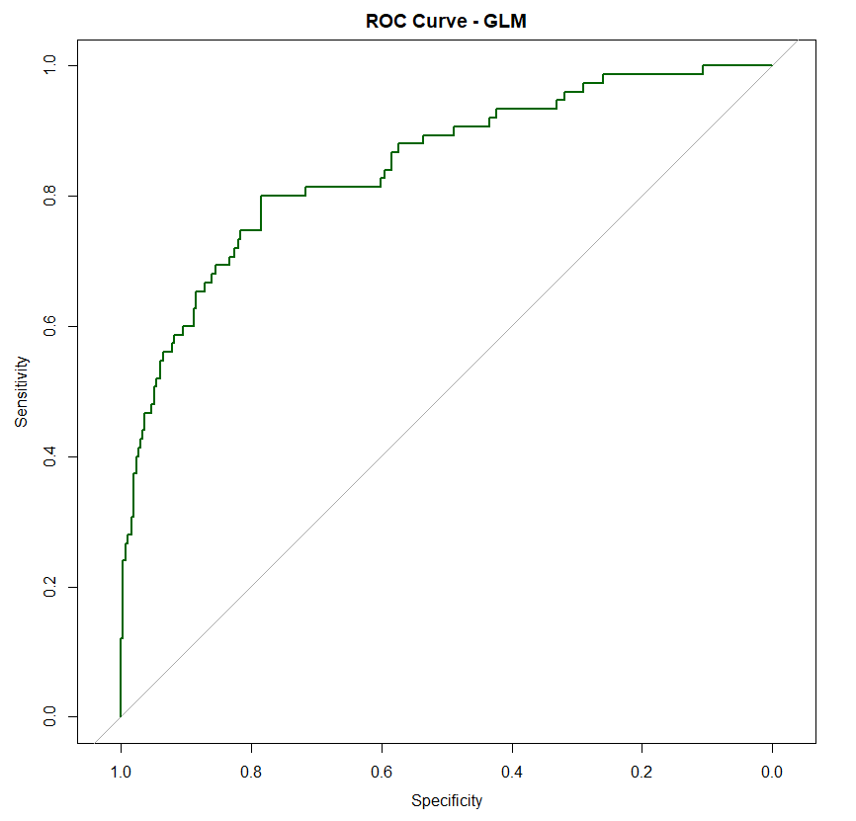
The ROC curve shows good discriminative ability. The curve rises quickly towards the top-left corner, indicating a strong model fit.

Support Vector Machine

A Support Vector Machine was trained using a radial basis function (RBF) kernel on the scaled dataset. The model aimed to classify employee attrition based on the available predictors.
Model Evaluation
Confusion Matrix and Classification Metrics
The confusion matrix and key statistics are shown below:
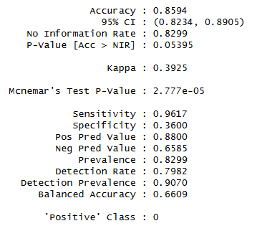
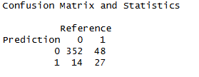

- Accuracy: 0.859
- Sensitivity: 0.962 (high ability to detect class 0)
- Specificity: 0.360 (lower performance on class 1)
- Kappa: 0.3925
- Balanced Accuracy: 0.661
- Positive Predictive Value: 0.88
- Negative Predictive Value: 0.659
The SVM shows strong overall accuracy, especially in predicting the majority class, though its specificity indicates some difficulty identifying class 1 correctly.

ROC Curve
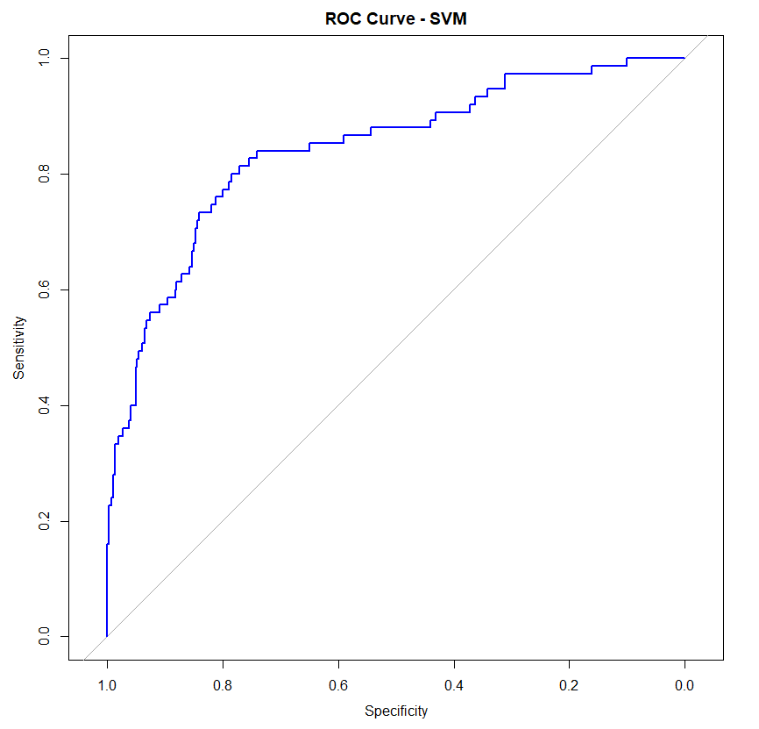

The ROC curve demonstrates good classification performance, with strong separation between the two classes.

Deep Learning Model (Neural Network)
A feedforward neural network was implemented using the keras package in R to model employee attrition as a binary classification problem. The aim was to assess whether a deep learning approach could improve predictive performance compared with traditional classification models. The target variable, Attrition, was converted into a binary indicator and one-hot encoded for the softmax output layer. The data was split into 80% training and 20% testing sets.

Model Architecture
A sequential neural network was constructed with the following structure:
- Input layer matching the number of predictors
- Dense hidden layer with 64 units and ReLU activation
- Dropout layer (30%)
- Dense hidden layer with 32 units and ReLU activation
- Dropout layer (20%)
- Output layer with 2 units and softmax activation

The model was trained for 100 epochs with a batch size of 32. Validation performance was monitored using the test set.

Training and Validation Accuracy and Loss

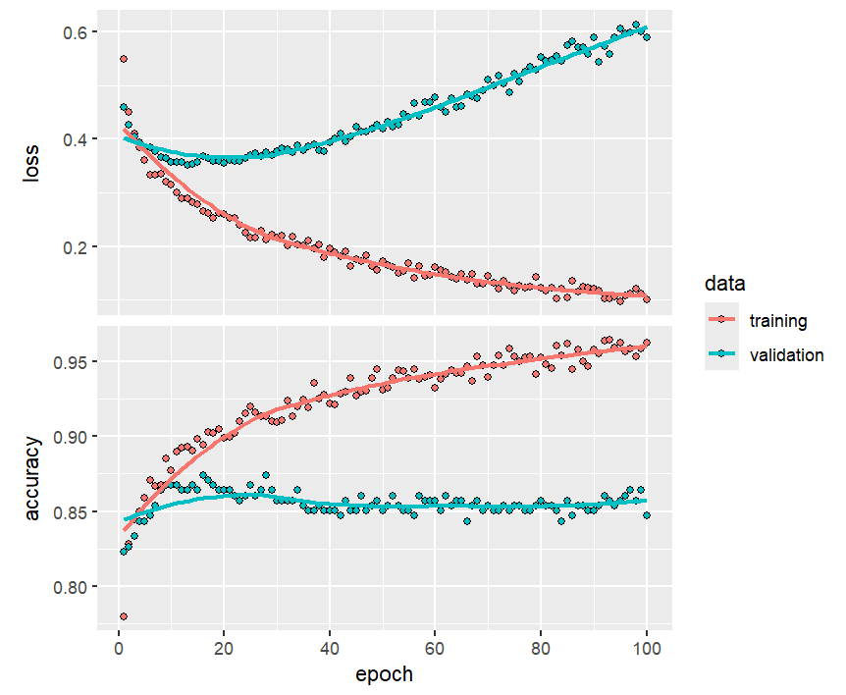
The plots show that training accuracy increases steadily while validation accuracy plateaus early. Validation loss begins to rise after approximately 20 epochs, indicating overfitting.

Model Performance

Confusion Matrix
The model performs well at predicting non-attrition cases but is less effective at identifying employees who leave, which is likely due to class imbalance.

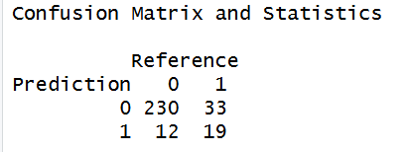

ROC Curve and AUC
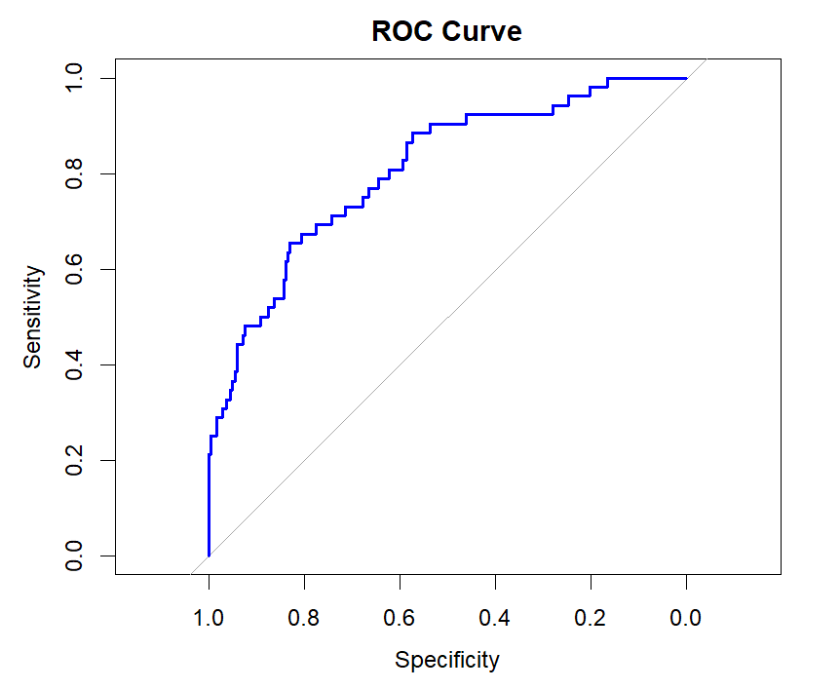

The model achieved an AUC of 0.807, indicating good class separation.
Key Metrics:
- Accuracy: 0.847
- Sensitivity: 0.950
- Specificity: 0.365
- Balanced Accuracy: 0.658
- AUC: 0.807

Conclusion
The neural network achieved strong overall accuracy and a good AUC score, suggesting reasonable predictive power. However, the imbalance between attrition and non-attrition cases led to weaker performance for the minority class. Evidence of overfitting was also observed, indicating that early stopping could further improve generalisation.

Model Comparison
All three classification models; GLM, SVM, and Neural Network were evaluated using the same train-test split and assessed on key performance metrics including accuracy, sensitivity, specificity, and AUC (Area Under the Curve).

Model | Accuracy | Sensitivity | Specificity | AUC
GLM | 87.76% | 0.973 | 0.413 | 0.845
SVM | 85.94% | 0.962 | 0.360 | 0.842
Neural Network | 84.12% | 0.961 | 0.341 | 0.807

- GLM performed best overall, achieving the highest accuracy (87.76%) and AUC (0.845). It was particularly strong in identifying the majority class (high sensitivity), though with relatively lower specificity.
- SVM showed competitive results, with a slightly lower AUC (0.842) and accuracy (85.94%). It maintained high sensitivity but still struggled with specificity, reflecting a tendency to misclassify the minority class.
- The Neural Network, despite its complex architecture, had the lowest performance among the three. It achieved the lowest AUC (0.807), indicating weaker discrimination between classes.

Conclusion
This report explored the use of three classification models; GLM, Support Vector Machine (SVM), and a Deep Learning Neural Network to predict employee attrition using a real-world HR dataset.
All models were trained on a processed dataset where key predictors such as age, overtime, job role, and job satisfaction showed significant relationships with attrition. After training and evaluation, the Generalized Linear Model (GLM) emerged as the best-performing model, achieving the highest accuracy and AUC. SVM followed closely, while the Neural Network, despite its added complexity, underperformed relative to the simpler models.
The GLM also offers the benefit of interpretability through its coefficients and odds ratios, making it useful for HR professionals who need both accurate predictions and insights into which factors contribute most to employee turnover.
In conclusion, the GLM model strikes the best balance between predictive power and practical application for attrition prediction in this instance.
Appendix
The full code, dataset, and project files are available at the following GitHub repository:
https://github.com/Bk2136/employee-attrittion-classification

